Horemheb Is the Exodus Pharaoh

C:\Users\Owner\Desktop\Horemheb.PNG

After comparing the dates assigned to the reigns of the Pharaohs provided by current Egyptology with the date of Moses' birth worked out by rabbinical scholarship,**1,2** it seems clear to me that Horemheb must have been the Exodus Pharaoh. But in a search of the internet and other sources, I found that historians generally don’t believe the Exodus is an historical event, and among other researchers, very few have claimed the Exodus Pharaoh to be Horemheb. Some have said he was Ramesses II, some have said Thutmosis III, some have claimed another Pharaoh, but very few have said, as far as I can tell, that he was Horemheb.

After looking into the history we think we know of the time around Horemheb, it seems to me that a compelling narrative can be built consistent with what has been learned from archaeology and other written historical records including (and especially) the Bible since it is the only record we have of the Exodus, I’m told. So here is my version of events.

According to most Egyptologists, Horemheb ruled from 1319 to 1292. The consensus of modern Rabbis is that Moses was born in 1391, and, according to the Bible record, confronted Pharaoh 80 years later in 1311—eight years after Horemheb took power.**3**

It’s been established that during his reign Horemheb committed *damnatio memoriae* against the former Amarna Pharaoh, Akhenaten. It is well established that Akhenaten’s son, Tutankhamun,**4** as well as Smenkhkare, Neferneferuaten and Ay had, during the years 1334 to 1319, already reversed many of Akhenaten’s reforms before Horemheb took power.

Nevertheless, Egypt was in turmoil over the status of the priesthood and the gods when Horemheb became Pharaoh.**5** Horemheb eventually reversed all of Akhenaten’s reforms and re-established traditional polytheism in an attempt to restore order.

During Horemheb’s first decade, as conditions in Egypt continued to incite civil unrest, the Hebrews, led and inspired by Moses, lobbied Horemheb to let them leave for their ancestral lands in Canaan.

After the Exodus described only in the Bible, Horemheb, with help from the polytheist priesthood, “erased” all history of the "monotheist" Akhenaten, his allies and fellow travelers like Moses. His and the priests’ obsession to destroy all records may have been fueled not only by outrage over the heresies of Akhenaten but also by the collapse of the economy and losses to the army during and after the Exodus.**6**

**The Exodus Story:**

Pharaoh Thutmosis IV died around 1390 BCE leaving a newborn son, Amenhotep III, to become Pharaoh. According to the Bible, the same year a daughter of Thutmosis IV, possibly Tentamun or Tiaa, found Moses floating in a basket on the Nile River. She brought Moses into the palace to be a playmate for the new Pharaoh. Soon after she located Moses’ mother and brought her also into the palace to wet-nurse Moses and, possibly, the baby Pharaoh.

So Amenhotep III and Moses grew up together, almost as brothers. When Moses was forty years old Amenhotep III died. His son, Amenhotep IV became Pharaoh. Moses then fled from Egypt, according to the Bible, to avoid trial for killing an overseer. He may also have worried that, as an adopted brother to Amenhotep III, Amenhotep IV might have considered him a rival to the throne.

The influence of religion by Moses and his mother on the Thutmosis IV family may have been considerable. After all, Amenhotep IV not only changed his name to Akhenaten to reflect his revolutionary (at the time) belief in a single creator god he called Aten, the Sun Orb, but he also suppressed all the existing polytheistic cults. He built a new city to honor Aten, now called Amarna. This move to a form of monotheism turned Egyptian society upside down and enraged the priestly class who depended on polytheism for their economic survival.

About 20 years after Akhenaten died—in 1335—Moses, at age 57, returned to Egypt. He found Egypt in chaos and rebellion due to outrage by the priests and population over the move away from polytheism. During the next 15 years Moses lived among the Hebrews, and by age 72 he had become their de facto leader. Horemheb meanwhile had become Pharaoh.

By age 80 Moses was challenging Horemheb to let the Hebrews leave Egypt. Eventually Horemheb did, issuing a directive—according to the Bible—that the general population provide the Hebrews with gold and silver as they left. Horemheb’s plan may have been to trap them against the marshes in the Sea of Reeds, annihilate them and recover their booty to stock the Egyptian treasury.

After an unexpected inundation7 cost him his army, Horemheb, with the encouragement of the priesthood, turned against the Amarna cults and started a *damnatio memoriae* against their Pharaoh, his allies and their temples.

When Horemheb died leaving no heir, the Ramesses family took over. Ramesses I, Seti I and Ramsesses II spent the next forty years continuing the *damnatio* by leveling the town of Amarna and its temples, destroying stelae and grinding down glyphs and cartouches that referred to anyone associated with the heretical Amarna one-god movement. They even sent armies into Canaan to hunt down Moses and the Hebrews in the homeland of their legendary Joseph.

Unknown to the Pharaohs, Moses didn’t go into Canaan but was instead, according to the Bible, hiding in the Sinai desert. The Pharaohs sent at least three armies into Canaan. Not finding Moses, they marched north to search in Syria, where the Hittites ambushed them. The Egyptians ended up conducting at least three campaigns against the Hittites. These campaigns financially exhausted and militarily weakened both the Egyptians and the Hittites.

Forty years after the Exodus, Moses died. By then Egypt had withdrawn from Canaan and Syria. According to the Bible, Joshua (Moses’ successor) walked the Hebrews out of the Sinai desert into Canaan. By 1259 BC—52 years after the Exodus—Egypt signed the famous peace treaty of Kadesh8 with the Hittites of Syria diminishing the most important existential threat to the new Israel by making it less likely Egypt would return to Canaan.

Fifty years later, in 1208 BC, they returned nevertheless. Ramesses' son, the aging Merenptah, decided to finish his family’s vendetta against the Hebrews and go to Canaan to do battle with the fledgling Israel. According to the "Merenptah Stelae" (found by Flanders Petrie and housed in the Cairo Museum) he "destroyed Israel's seed" such that "they were no more." This assessment turned out to be exaggerated. It is interesting to note that the inscriptions of the encounter were carved on the back of a stelae once belonging to Amenhotep III, Moses "brother."

To conclude, in light of the Bible account of the Passover and the killing of the first-born, it is noteworthy to mention that tomb examiners found the fetus of Horemheb's son and heir-apparent inside his wife's mummified body.

No records of Moses or the Exodus itself, in hieroglyphs or Egyptian script, have been found.

Bill Clack

1. Rabbinical Judaism uses the Seder Olam from 2nd century CE to date Biblical events. According to the Seder Olam, 832 BCE is the date of the start of construction of the first temple built by Solomon. 1311 BCE is the date of the Exodus. The interval between these two dates agrees closely to the interval described in I Kings, 6:1.

2. These dates agree well with the latest archaeological evidence according to Thomas L Thomson and Israel Finkelstein. Many secular sources, including modern fundamentalist millennial Christian sources, place the temple build 165 years earlier to 1000 BCE.

3. Some Egyptologists think Horemheb may have taken power in 1306 (13 years later) based on dates on wine bottles from his winery found in his tomb (which is 5 years after the Exodus as calculated by the Rabbis). If 1306 is right, the campaign of *damnatio memoriae* initiated by Horemheb against Akhenaten would have to have reached to a now forgotten and undiscovered Pharaoh who must have ruled for 13 years after Ay. A possible candidate for the missing Pharaoh would be Nakhtmin. Manethos, in his 'Egyptian History', said that Tutankhamen had a son, Acencheris, who ruled 13 years, but Egyptologists say no physical evidence at all supports this idea. However, there is evidence that the reign of Thutmosis IV began 13 years later than commonly believed (in 1388) if long standing and as yet unsettled arguments about the reign of his father, Amenhotep II get resolved. Then the dates add correctly and there would be no undiscovered Pharaoh. In any event, choose any scenario you like, the dates will lead to Horemheb as Pharaoh during the Exodus.

4. Tutankhamun is the only Pharaoh whose tomb remained essentially undamaged until modern times. The spectacular nature of his tomb and sarcophagus has brought intense interest to the 18th dynasty and serves, to my mind, as a pointer from God to Moses and Akhenaten.

5. The surviving copy of the Ipuwer Papyrus, dating to the 19th dynasty (13th century BCE), may actually describe the conditions in Egypt during the Amarna/post-Amarna period before Horemheb took power.

6. Before becoming Pharaoh Horemheb commanded the army under Pharaohs Tutankhamun and Ay.

7. Although the yearly inundation of the Nile was closely watched, recorded and predictable, unexpected inundations occurred from time to time in branches of the Nile in the Delta region where the Exodus took place.

8. The Egyptian–Hittite peace treaty was concluded between Egyptian Pharaoh Ramesses II and Hittite King Hattusili III in or around 1259 BC, sixteen years after the end of hostilities. It is the oldest surviving written treaty in existence.

**KING’S LIST REFERENCE**

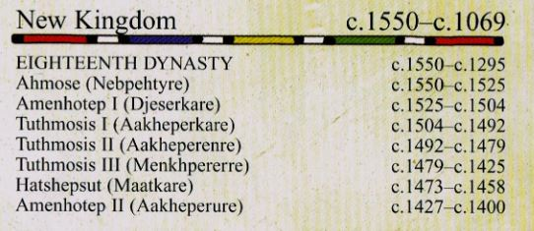

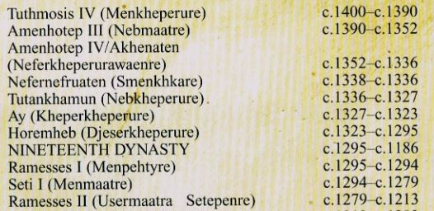

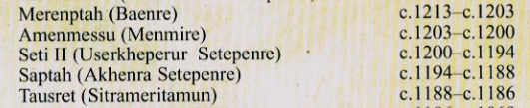

**GENEALOGY REFERENCE**

