Horemheb Is the Exodus Pharaoh

C:\Users\Owner\Desktop\Horemheb.PNG

After comparing the dates assigned to the reigns of the Pharaohs provided by current Egyptology with the date of Moses' birth worked out by rabbinical scholarship, it seems to me that Horemheb could have been the Exodus Pharaoh. But in a search of the internet and other sources, I found that historians generally don’t believe the Exodus is an historical event, and among other researchers, very few have claimed the Exodus Pharaoh to be Horemheb. Some have said he was Ramesses II, some have said Thutmosis III, some have claimed another Pharaoh, but very few have said, as far as I can tell, that he was Horemheb.

After looking into the history we think we know of the time around Horemheb, it seems to me that a compelling narrative of the Exodus and Horemheb can be built consistent with what has been learned from archaeology and other written historical records including (and especially) the Bible, since it is the only record we have of the Exodus, I'm told.

According to most Egyptologists, Horemheb ruled from 1319 to 1292. Many Rabbis say that Moses was born in 1391, and, according to the Bible record, confronted Pharaoh 80 years later in 1311—eight years after Horemheb took power.

Rabbinical Judaism uses the Seder Olam from 2nd century CE to date Biblical events. According to the Seder Olam, 832 BCE is the date of the start of construction of the first temple built by Solomon. 1311 BCE is the date of the Exodus. The interval between these two dates agrees closely to the 480 year interval described in I Kings, 6:1.

To be fair, modern fundamentalist millennial Christian sources place the start of temple construction to 1000 BCE, but this date strains credibility, because it was established to fit the theory of millennialism in which history is divided into seven one-thousand year “days.”

Mainstream historians have said that during his reign Horemheb intensified a *damnatio memoriae* (striking from the memory) against the former Amarna Pharaoh, Akhenaten, begun under Akhenaten’s son, Tutankhamun, and the Pharaohs that followed—Smenkhkare, Neferneferuaten and Ay. These Pharaohs had reversed many, but not all, of Akhenaten’s reforms during the years 1334-1319 creating uncertainty and turmoil over the status of the priesthood and the gods. But Horemheb took the reversal to a whole new level restoring order by reversing all of Akhenaten’s reforms and re-establishing traditional polytheism throughout the whole of Egypt.

The surviving copy of the Ipuwer Papyrus, dating to the 19th dynasty (13th century BCE), may actually describe the conditions in Egypt during the Amarna/post-Amarna period before and after Horemheb took power. It may have been during this period that the Hebrews, led by Moses, lobbied Horemheb to let them leave for their ancestral lands in Canaan.

It should be noted: historians have established that before Horemheb became Pharaoh he commanded the army under Pharaohs Tutankhamun and Ay. After the Exodus described in the Bible, Horemheb, fed-up with the unrest and loss of his army, enlisted his allies, the polytheistic priests and their cults to erase all history of the "monotheist" Akhenaten, his allies and supporters, like Moses. Horemheb’s and the priests’ obsession to destroy records may have been fueled not only by outrage over the heresies of Akhenaten but also by the collapse of the economy and losses to the army during and after the Exodus.

**The Exodus Story:**

Pharaoh Thutmosis IV died around 1390 BCE leaving a newborn son, Amenhotep III, to become Pharaoh. According to the Bible, the same year a daughter of Thutmosis IV, possibly Tentamun or Tiaa, found Moses floating in a basket on the Nile River. She brought Moses into the palace to be a playmate for the new Pharaoh. Soon after she located Moses’ mother and brought her into the palace to wet-nurse Moses and, possibly, the baby Pharaoh, Amenhotep III. So Amenhotep III and Moses grew up together, almost as brothers.

The influence of religion by Moses’ mother—a monotheistic Jewish woman—on the Thutmosis IV family may have been considerable. No one can know for sure, but what followed—the move to monotheism by the younger brother of Amenhotep III—might be understood as evolving from her influence. No one can really know, but her influence over a period of ten or twenty years would help make sense out of the history that followed.

When Moses was forty years old Amenhotep III died. His son, Amenhotep IV became Pharaoh. Moses fled from Egypt, according to the Bible, to avoid trial for killing an overseer. But he may have worried that, as an adopted brother to Amenhotep III, Amenhotep IV considered him a rival to the throne.

The first thing Amenhotep IV did after becoming Pharaoh was change his name to Akhenaten to reflect his revolutionary belief in a single creator god he called Aten, the Sun Orb. He then aggressively suppressed all the existing polytheistic cults. He built a new city, Amarna, to honor Aten. This move to a form of monotheism turned Egyptian society upside down and enraged the priestly class who depended on polytheism for their economic survival.

In 1335 Akhenaten died and Moses, age 56, returned to Egypt. He found Egypt in chaos and rebellion due to outrage by the priests and population over the move away from polytheism. During the next 15 years Moses lived among the Hebrews, and by age 70 he had become their de facto leader. Horemheb meanwhile had become Pharaoh.

By age 80 Moses was challenging Horemheb to let the Hebrews leave Egypt. Eventually Horemheb did, issuing a directive—according to the Bible—that the general population provide the Hebrews with gold and silver as they left. Horemheb’s plan may have been to trap them against the marshes in the Sea of Reeds, annihilate them and recover their booty to stock the Egyptian treasury.

After an unexpected inundation cost him his army, Horemheb, with the encouragement of the priesthood, turned against the Amarna cults and started the *damnatio memoriae* against their Pharaoh, his allies and their temples.

It should be noted that although the yearly inundation of the Nile was closely watched, recorded and predictable, unexpected inundations occurred from time to time in branches of the Nile in the Delta region where the Exodus took place.

When Horemheb died leaving no heir, the Ramesses family took over. Ramesses I, Seti I and Ramsesses II spent the next forty years continuing the *damnatio* by leveling the town of Amarna and its temples, destroying stelae and grinding down glyphs and cartouches that referred to anyone associated with the heretical Amarna one-god movement. They also sent armies into Canaan to hunt down Moses and the Hebrews in the homeland of their legendary Joseph.

Unknown to the Pharaohs, Moses didn’t go into Canaan but was instead, according to the Bible, hiding in the Sinai desert. The Pharaohs sent at least three armies into Canaan. Not finding Moses, they marched north to search in Syria, where the Hittites ambushed them. The Egyptians ended up conducting at least three campaigns against the Hittites. These campaigns financially exhausted and militarily weakened both the Egyptians and the Hittites.

Forty years after the Exodus, Moses died. By then Egypt had withdrawn from Canaan and Syria. According to the Bible, Joshua (Moses’ successor) walked the Hebrews out of the Sinai desert into Canaan.

By 1259 BC—sixteen years after the end of hostilities and fifty-two years after the Exodus—Egypt signed the famous peace treaty of Kadesh with the Hittites of Syria. The peace treaty, concluded between Egyptian Pharaoh Ramesses II and the Hittite King Hattusili III, is the oldest surviving written treaty in existence. It diminished the most important existential threat to the new Israel by making it less likely Egypt would return to Canaan.

Fifty years later, in 1208 BC, Egypt returned nevertheless. Ramesses' son, the aging Merenptah, decided to finish his family’s vendetta against the Hebrews and go to Canaan to do battle with the fledgling Israel. According to the "Merenptah Stelae" (found by Flanders Petrie and housed in the Cairo Museum) he "destroyed Israel's seed" such that "they were no more." This assessment turned out to be exaggerated.

It is interesting to note that these inscriptions were carved on the back of a stelae that once belonged to Amenhotep III, Moses "brother." Merenptah simply turned it around and used it as his own.

It is also interesting—in light of the Bible account of the Passover and the killing of the first-born by the Angel of Death—to remember that tomb examiners found the fetus of Horemheb's son and heir-apparent inside his wife's mummified body. As a result, Horemheb had no heir, and the Ramesses’ family was able to take power.

No records of Moses or the Exodus itself, in hieroglyphs or Egyptian script, have been found.

Bill Clack

**KING’S LIST REFERENCE**

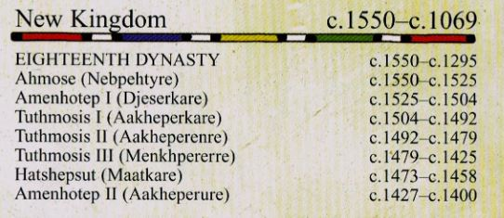

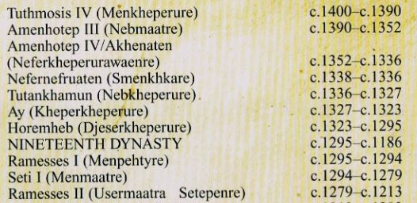

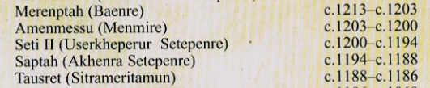

**GENEALOGY REFERENCE**

